FIRST CLASS ● DATED MATERIAL

Karen Sanders - FTS
13120 SE Wiese Rd
Damascus, OR 97089

(503) 819 - 5217
allagantesilkens@yahoo.com

Directions to the Site:
From the North or South: From I-5 take the I-205 Exit.

Travel to the Hwy 224 – Estacada/Damascus Exit and head east.

Go east approximately 7 miles to Damascus.

From the main intersection of the town of Damascus (Safeway on left hand side of road and McDonalds on right hand side of road) continue to the first road on the left which is WIESE RD.

Turn left onto Wiese and travel approximately 3/4 miles to ALLAGANTE SILKENS 13120 SE Wiese Rd.) on the right side of the road.

You will travel down a gravel drive and through a gate which you will have to OPEN AND CLOSE, then up the drive the rest of the way.

No one will be allowed on the field without the express permission of the field chairman, except the appointed field committee. A $5 fine will be charged to anybody caught not picking up after their dog or leaving garbage on the field. Anybody exhibiting unsportsmanlike behavior will be excused from the field and may be subject to further disciplinary action.
These rules will be strictly enforced.

PREMIUM LIST

EARLY ENTRIES CLOSE Thursday, June 25th at 6pm

at the FTS’s address

DAY OF TRIAL ENTRIES CLOSE Monday, June 29th at 9:30am
at the FTS’s Table

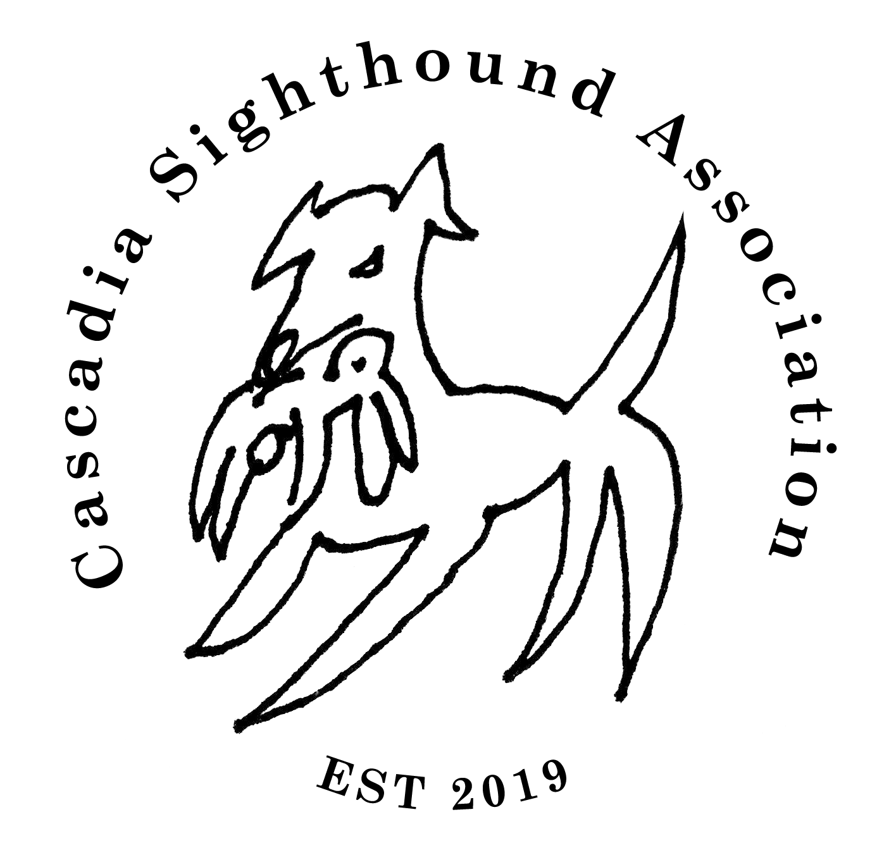
Region 1

ASFA ALL-BREED FUN TRIAL

NO ASFA POINTS SHALL BE AWARDED AT THIS FUN TRIAL

June 29th, 2020

Allagante Silkens
13120 SE Wiese Rd
Damascus, OR 97089

Early Entry Fee…..…..…..…..…..…..…...$2
Day-of-Entry Fee..…..…..…..……………..$3
Certification Runs…..…..…..…………..…$5

Permission has been granted by the American Sighthound Field Association
for the holding of this event under ASFA Rules and Regulations.
Audrey Silverstein, Chairperson, ASFA Scheduling Committee

Go to www.ASFA.org
for online Rulebook, Policies, Contacts, Clubs,
Trial Schedules, Trial Results & much more.

CSA
Cascadia Sighthound Association
President………………………………………………… Jonathan P. Buchanan
Vice President………………………………………………………… Pauline Ng
Secretary…………………………………………………………………. Kelly Ng
Treasurer…………………………………………………………… Jenelle Olsen

JUDGES & ASSIGNMENTS
Charles Roberts……………………………….………………….…Oregon City, OR
Paul Sanders………………………………………………….……… Damascus, OR
S = Single Judge * = Provisional Judge # = Canadian Judge
MONDAY
JUDGE | A | Az | Ba | B | C | G | Ib | Iw | IG | P | R | S | SD | Sl | SW | W | Sgl | Ltd
Charles | X | X | X | X | X | X | X | X | X | X | X | X | X | X | X | X | X | X
Paul | X | X | X | X | X | X | X | X | X | X | X | X | X | X | X | X | X | X

FIELD COMMITTEE
Field Trial Chairman | Jonathan P. Buchanan
Field Trial Secretary | Karen Sanders
Lure Operators | Greg Behrens & Jonathan P. Buchanan

TRIAL HOURS: 8AM UNTIL AFTER RIBBONS ARE AWARDED.
Day of Trial entries close at 9am
Substitutions (same owner) until June 29th at 9:45am
ROLL CALL: PROMPTLY at 10 am

ENTRIES WILL NOT BE ACKNOWLEDGED BY RETURN MAIL OR PHONE;
ENTRIES MAY BE ACKNOWLEDGED BY E-MAIL
IF OWNER FORWARDS E-MAIL ADDRESS.

Ribbons: 1st = Rose, 2nd = Brown, 3rd – Light Green, 4th = Gray, NBQ = Light Pink, High Scoring Single = Light Blue, Best of Breed = Orange, Best in Field = Lavender

ELIGIBLE BREEDS & REGISTRY
Only purebred Afghan Hounds, Azawakhs, Basenjis, Borzoi, Cirneco dell’Etna, Greyhounds, Ibizan Hounds, Irish Wolfhounds, Italian Greyhounds, Pharaoh Hounds, Rhodesian Ridgebacks, Salukis, Scottish Deerhounds, Silken Windhounds, Sloughis, Whippets may be entered in the regular stakes.

Limited breeds may be entered in the Limited Stake or the Singles Stake. Limited breeds currently include purebred Chart Polski, Galgo Español, Magyar Agar, Peruvian Inca Orchid, Portuguese Podengo (Pequeno), Portuguese Podengo (Medio & Grande), and must be individually registered with the appropriate registry.

All entries shall be individually registered with the AKC (ILP/PAL included), the NGA, the UKC, the FCI, an ASFA-recognized foreign or ASFA Board approved registry, or possess a CRN from the SPDBS. A photocopy of acceptable registry must be submitted with each hound’s first ASFA field trial entry; this requirement is waived for hounds registered with the NGA.

REGULAR STAKES OFFERED
OPEN STAKE: Any eligible sighthound, excluding ASFA Field Champions of record that has met the certification requirements.
FIELD CHAMPION STAKE: Any ASFA Field Champion
VETERAN STAKE: Any eligible hound whose age is at least six years, except Irish Wolfhounds whose age shall be at least five years, and Afghan Hounds, Rhodesian Ridgebacks, Salukis and Whippets whose age shall be at least seven years, record that has obtained met the certification requirements. Points go toward V-FCh or V-LCM titles.
LIMITED STAKE: Any eligible sighthound of a Limited breed that has met certification requirements. Not eligible to compete in Best of Breed or Best in Field.
SINGLES STAKE: Any eligible sighthound including those disqualified to run in other stakes. Each hound runs alone. Not eligible for Best of Breed or Best in Field. Hounds are eligible to earn TCP and CPX titles from the Singles stake. Limited breeds are not eligible for these titles.

BEST IN FIELD WILL BE OFFERED

Conditions of Entry: All entries must be one year or older on the day of the trial ● Stakes will be split into flights by public random draw if the entry in any regular stake is 20 or more ● Bitches in season, lame hounds and hounds with breed disqualifications will be excused at roll call. Spayed, neutered, monorchid or cryptorchid hounds without breed disqualifications may be entered; hounds with breed disqualifications are not eligible to enter except in the Single Stake ● Hounds not present at the time of roll call will be scratched ● All hounds will run twice, in trios if possible or braces (except in the Single Stake), unless excused, dismissed or disqualified.

Equipment: Type of lure machine: battery-powered continuous-loop system. ● Type of lures: highly-visible white plastic strips ● Back-up equipment will be available.

Veterinarian on call:
Northwest Veterinary Specialists (24/7 emergency service)
16756 SE 82nd Drive
Clackamas, OR 97015
503-656-3999

COURSE PLANS

Monday Course:
The club reserves the right to alter the course due to weather and/or field conditions. The course will be revised for final and again for run offs or at the discretions of the judges.
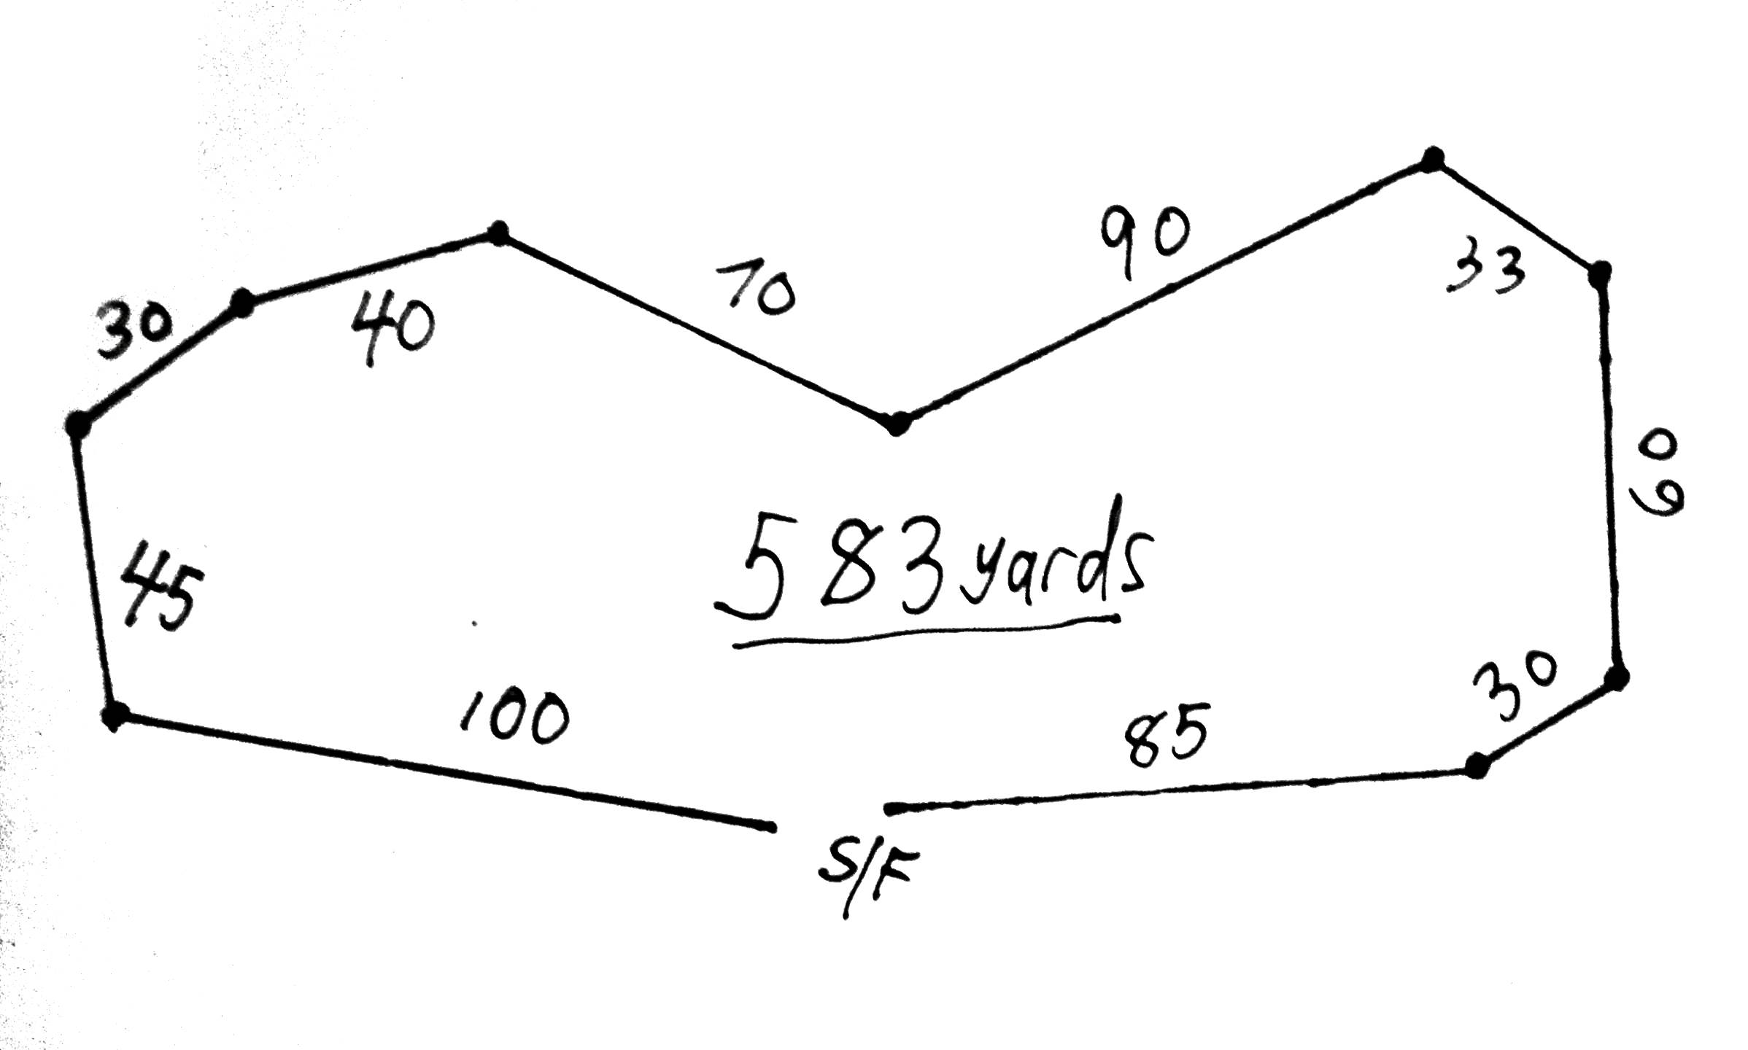

The course plan is 583 yards. A drag-style lure machine will be used.

OTHER INFORMATION

ACCOMMODATIONS

Camping (no hookups) is allowed on the field at no charge.

HOTELS: There are many hotels in the vicinity. The following is a list of possible pet friendly places, all of which are within about 20 minutes or less of driving time to the event site. Since pet rooms may be limited, we strongly suggest you make reservations well in advance.

Motel 6 1610 NW Frontage Road, Troutdale, OR 503-665-2254 www.moteI6.com

Comfort Suites 15929 SE McKinley Ave, Clackamas, OR 97015 503-723-6450 www.comfortsuites.com

Super 8 121 NE 181st Avenue, Portland, OR 97230 503-661-5100 www.super8.com

Days Inn 24124 SE Stark St.; Gresham, OR 97030 503-465-1515 www.daysinn.com

Clackamas Inn & Suites 160lO E 82nd Dr., Clackamas, OR 503-650-5340 www.clackamasinn.com
OFFICIAL AMERICAN SIGHTHOUND FIELD ASSOCIATION ENTRY FORM

Cascadia Sighthound Association
Monday, June 29th, 2020
Early entries close June 25th at the FTS’s residence.
Early entry fees: $2; Day of trial entry fee: $3;
(Substitutions, same owner, until June 29th, 2020 at 9:45am)
Make checks payable (in US funds) to CSA and mail to:
Karen Sanders – FTS • 13120 SE Wiese Rd, Damascus OR 97089
POINTS AND PLACEMENTS DO NOT COUNT FOR THIS FUN TRIAL
Fee Paid ______ The Field Secretary cannot accept conditional, unsigned, incomplete or unpaid entries; please check your completed entry carefully.
Breed: | Call Name:
Registered Name of Hound:

Stake:   Open  FCH  Veteran  Single  Limited |  | Additional Stakes   Kennel  Breeder  Bench
Registration Number: (please write in registering body before number)

 If possible, please  separate my hounds | Date of  Birth: | Sex:   Dog  Bitch
Name of actual owner(s):

Address: |  | Phone:
City: |  | State: | Zip:
^{E-mail (Optional)} |  | (Optional) Region of Residence:
Emergency Contact Name and Phone (Optional)

 Check if this is the first ASFA trial for this hound. Attach a Hound Certification or waiver if entered in Open, Veterans, Limited.
 Check if this is a first-time entry, a copy of the official Registration of this hound must accompany this entry unless NGA.
 Check if any information has changed since the last ASFA trial entry. Regarding _______________
 Check if this hound has been dismissed within the last 6 trials entered. Must be marked in order to qualify for a “clean” trial requirement.

I CERTIFY that I am the actual owner of this dog, or that I am the duly authorized agent of the actual owner whose name I have entered above. In consideration of the acceptance of this entry and the opportunity to have this dog judged and to win prize money, ribbons, or trophies, I (we) agree to abide by the rules and regulations of the American Sighthound Field Association in effect at the time of this lure field trial, and by any additional rules and regulations appearing in the premium list for this lure field trial. I (we) agree that the club holding this lure field trial has the right to refuse this entry for cause, which the club shall deem to be sufficient. I (we) agree to hold this club, its members, directors, governors, officers, agents or other functionaries, any employees of the aforementioned parties and the owner(s) of the trial premises or grounds harmless from any claim for loss or injury which may be alleged to have been caused directly or indirectly to any person or thing by the act of this dog while in or upon the lure field trial premises or grounds or near any entrance thereto and I (we) personally assume all responsibility and liability for any such claim, and I (we) further agree to hold the aforementioned parties harmless from any claim loss of this dog by disappearance, theft damage or injury be caused or alleged to be caused by the negligence of the club or any of the aforementioned parties or by the negligence of any person or any other cause or causes. I (we) certify and represent that the dog entered is not a hazard to person or other dogs. This entry is submitted for acceptance of the forgoing representations and agreements.

SIGNATURE of owner or his agent
duly authorized to make this entry __________
OFFICIAL AMERICAN SIGHTHOUND FIELD ASSOCIATION ENTRY FORM

Cascadia Sighthound Association
Monday, June 29th, 2020
Early entries close June 25th at the FTS’s residence.
Early entry fees: $2; Day of trial entry fee: $3;
(Substitutions, same owner, until June 29th, 2020 at 9:45am)
Make checks payable (in US funds) to CSA and mail to:
Karen Sanders – FTS • 13120 SE Wiese Rd, Damascus OR 97089
POINTS AND PLACEMENTS DO NOT COUNT FOR THIS FUN TRIAL
Fee Paid ______ The Field Secretary cannot accept conditional, unsigned, incomplete or unpaid entries; please check your completed entry carefully.
Breed: | Call Name:
Registered Name of Hound:

Stake:   Open  FCH  Veteran  Single  Limited |  | Additional Stakes   Kennel  Breeder  Bench
Registration Number: (please write in registering body before number)

 If possible, please  separate my hounds | Date of  Birth: | Sex:   Dog  Bitch
Name of actual owner(s):

Address: |  | Phone:
City: |  | State: | Zip:
^{E-mail (Optional)} |  | (Optional) Region of Residence:
Emergency Contact Name and Phone (Optional)

 Check if this is the first ASFA trial for this hound. Attach a Hound Certification or waiver if entered in Open, Veterans, Limited.
 Check if this is a first-time entry, a copy of the official Registration of this hound must accompany this entry unless NGA.
 Check if any information has changed since the last ASFA trial entry. Regarding _______________
 Check if this hound has been dismissed within the last 6 trials entered. Must be marked in order to qualify for a “clean” trial requirement.

I CERTIFY that I am the actual owner of this dog, or that I am the duly authorized agent of the actual owner whose name I have entered above. In consideration of the acceptance of this entry and the opportunity to have this dog judged and to win prize money, ribbons, or trophies, I (we) agree to abide by the rules and regulations of the American Sighthound Field Association in effect at the time of this lure field trial, and by any additional rules and regulations appearing in the premium list for this lure field trial. I (we) agree that the club holding this lure field trial has the right to refuse this entry for cause, which the club shall deem to be sufficient. I (we) agree to hold this club, its members, directors, governors, officers, agents or other functionaries, any employees of the aforementioned parties and the owner(s) of the trial premises or grounds harmless from any claim for loss or injury which may be alleged to have been caused directly or indirectly to any person or thing by the act of this dog while in or upon the lure field trial premises or grounds or near any entrance thereto and I (we) personally assume all responsibility and liability for any such claim, and I (we) further agree to hold the aforementioned parties harmless from any claim loss of this dog by disappearance, theft damage or injury be caused or alleged to be caused by the negligence of the club or any of the aforementioned parties or by the negligence of any person or any other cause or causes. I (we) certify and represent that the dog entered is not a hazard to person or other dogs. This entry is submitted for acceptance of the forgoing representations and agreements.

SIGNATURE of owner or his agent
duly authorized to make this entry __________
AMERICAN SIGHTHOUND FIELD ASSOCIATION  HOUND CERTIFICATION  Rule effective October 1, 1994: Ch. V, Sec. 4 (a) OPEN STAKE: To be eligible to enter the open stake, a hound must have been certified by a licensed judge within the year preceding the closing date for the entry or have previously competed in the Open Stake. This eligibility requirement also applies to a hound entered in the Limited or Veteran Stake, which has not competed in Open previously. Please complete this portion of this form and attach it to the entry form for the hound’s first entry, including an entry for a Fun Trial.  Registered Name of Hound:  Registration Number: _________________________ Breed:  Registered Owner’s Name:  I hereby certify that on (date) __________________, the above named hound completed a lure course of at least 500 yards, running with another hound of the same breed (or another breed with a similar running style). During the course the above named hound showed no inclination to interfere with the other hound. I further certify that I am a licensed judge for the ASFA.  Name of Licensed Judge:  Signature: Date:  I hereby certify that the hound running in the certification course is the hound identified above and that information provided on this form is true and correct.  Signature: Date:  Owner or Authorized Agent of Hound  This certification form must be attached to the entry form the first time this hound is entered in an open, limited, or veteran stake. Any hound entered in open, limited, or veteran (as a first time entered hound), which has not been certified, shall be declared ineligible by the records coordinator and shall forfeit any points and placements awarded.  PLEASE RETAIN A COPY FOR YOUR RECORDS.  AMERICAN SIGHTHOUND FIELD ASSOCIATION  HOUND CERTIFICATION WAIVER  Waiver of Requirement: This requirement will be waived for a hound that has earned a lure coursing title from another recognized organization, if such title requires competition, and if a waiver for such title has been approved by the ASFA, or a CKC Hound Certification Form. If your hound qualifies for a waiver, complete this portion of this form and attach it to your entry form. Proof of waivers must accompany this certification form.  Registered Name of Hound:  Registration Number: _________________________ Breed:  Registered Owner’s Name:  CKC: FCH FCHX  AKC: QC SC FC  Hound Certification previously submitted.  I hereby certify that the hound identified above has completed the requirements for the title indicated above (or that the required Certification was previously submitted) and that the information provided on this form is true and correct.  Signature: _______________________________________________ Date:  Owner or Authorized Agent of Hound |  | AMERICAN SIGHTHOUND FIELD ASSOCIATION  HOUND CERTIFICATION  Rule effective October 1, 1994: Ch. V, Sec. 4 (a) OPEN STAKE: To be eligible to enter the open stake, a hound must have been certified by a licensed judge within the year preceding the closing date for the entry or have previously competed in the Open Stake. This eligibility requirement also applies to a hound entered in the Limited or Veteran Stake, which has not competed in Open previously. Please complete this portion of this form and attach it to the entry form for the hound’s first entry, including an entry for a Fun Trial.  Registered Name of Hound:  Registration Number: _________________________ Breed:  Registered Owner’s Name:  I hereby certify that on (date) __________________, the above named hound completed a lure course of at least 500 yards, running with another hound of the same breed (or another breed with a similar running style). During the course the above named hound showed no inclination to interfere with the other hound. I further certify that I am a licensed judge for the ASFA.  Name of Licensed Judge:  Signature: Date:  I hereby certify that the hound running in the certification course is the hound identified above and that information provided on this form is true and correct.  Signature: Date:  Owner or Authorized Agent of Hound  This certification form must be attached to the entry form the first time this hound is entered in an open, limited, or veteran stake. Any hound entered in open, limited, or veteran (as a first time entered hound), which has not been certified, shall be declared ineligible by the records coordinator and shall forfeit any points and placements awarded.  PLEASE RETAIN A COPY FOR YOUR RECORDS.  AMERICAN SIGHTHOUND FIELD ASSOCIATION  HOUND CERTIFICATION WAIVER  Waiver of Requirement: This requirement will be waived for a hound that has earned a lure coursing title from another recognized organization, if such title requires competition, and if a waiver for such title has been approved by the ASFA, or a CKC Hound Certification Form. If your hound qualifies for a waiver, complete this portion of this form and attach it to your entry form. Proof of waivers must accompany this certification form.  Registered Name of Hound:  Registration Number: _________________________ Breed:  Registered Owner’s Name:  CKC: FCH FCHX  AKC: QC SC FC  Hound Certification previously submitted.  I hereby certify that the hound identified above has completed the requirements for the title indicated above (or that the required Certification was previously submitted) and that the information provided on this form is true and correct.  Signature: _______________________________________________ Date:  Owner or Authorized Agent of Hound
Sec-06 rev 02/19©
AMERICAN SIGHTHOUND FIELD ASSOCIATION
HOUND CERTIFICATION
Rule effective October 1, 1994: Ch. V, Sec. 4 (a) OPEN STAKE: To be eligible to enter the open stake, a hound must have been certified by a licensed judge within the year preceding the closing date for the entry or have previously competed in the Open Stake. This eligibility requirement also applies to a hound entered in the Limited or Veteran Stake, which has not competed in Open previously. Please complete this portion of this form and attach it to the entry form for the hound’s first entry, including an entry for a Fun Trial.
Registered Name of Hound:
Registration Number: _________________________ Breed:
Registered Owner’s Name:

I hereby certify that on (date) __________________, the above named hound completed a lure course of at least 500 yards, running with another hound of the same breed (or another breed with a similar running style). During the course the above named hound showed no inclination to interfere with the other hound. I further certify that I am a licensed judge for the ASFA.
Name of Licensed Judge:
Signature: Date:
I hereby certify that the hound running in the certification course is the hound identified above and that information provided on this form is true and correct.
Signature: Date:
Owner or Authorized Agent of Hound
This certification form must be attached to the entry form the first time this hound is entered in an open, limited, or veteran stake. Any hound entered in open, limited, or veteran (as a first time entered hound), which has not been certified, shall be declared ineligible by the records coordinator and shall forfeit any points and placements awarded.

PLEASE RETAIN A COPY FOR YOUR RECORDS.
AMERICAN SIGHTHOUND FIELD ASSOCIATION
HOUND CERTIFICATION WAIVER

Waiver of Requirement: This requirement will be waived for a hound that has earned a lure coursing title from another recognized organization, if such title requires competition, and if a waiver for such title has been approved by the ASFA, or a CKC Hound Certification Form. If your hound qualifies for a waiver, complete this portion of this form and attach it to your entry form. Proof of waivers must accompany this certification form.

Registered Name of Hound:
Registration Number: _________________________ Breed:
Registered Owner’s Name:
CKC: FCH FCHX
AKC: QC SC FC
Hound Certification previously submitted.
I hereby certify that the hound identified above has completed the requirements for the title indicated above (or that the required Certification was previously submitted) and that the information provided on this form is true and correct.
Signature: _______________________________________________ Date:
Owner or Authorized Agent of Hound

Sec-06 rev 02/19©

